PCI Internal Stakeholder Dashboard
As part of RSA Archer 6.8 PCI Management release, a new iView was created for the PCI Internal Stakeholder dashboard within the PCI Management use case. If you are upgrading from RSA Archer 6.7 or an earlier version to 6.8, please follow the manual steps below to add the image to your instance.
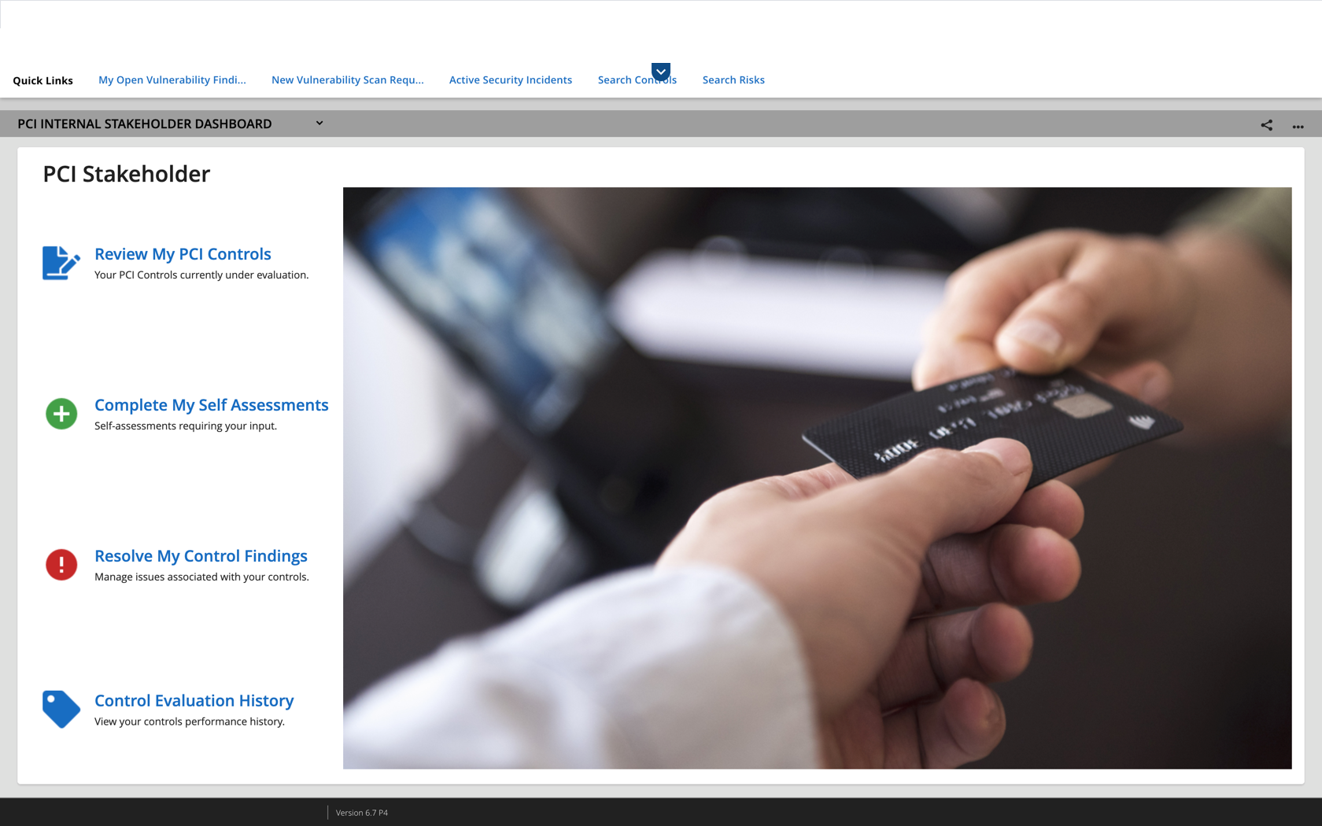

- Please ensure to install the RSA Archer 6.8 PCI Management use case package.
- Once the package is installed successfully, save the image file from the package, PCI_Internal_Stakeholder.jpg, to any location.
- Login to RSA Archer.

After logging in to RSA Archer, use one of the following methods to apply the graphic.

Apply graphic using the administration menu
- Go to Administration -> Workspaces and Dashboard -> Global iViews->.
- Click the PCI Stakeholder iView.
- In the General tab, go to Options.
- Select the ellipsis (…) in the Background field.
- Click Add New.
- In the File to Upload area, select the newly-available image PCI_Internal_Stakeholder.jpg from the saved location and click OK.
- In the Available Graphics area, select this image and click OK.
- Click Save.
OR

Apply graphic using the dashboard menu
- Navigate to the IT Security Risk Management workspace.
- Select the PCI Internal Stakeholder Dashboard from the menu.
- Click the iView Options menu ->Edit Properties ->.
- Select the ellipsis (…) in the Background field.
- Click Add New.
- In the File to Upload area, select the newly-available image PCI_Internal_Stakeholder.jpg from the saved location and click OK.
- In the Available Graphics area, select this image and click OK.
- Click Save.
- Click OK.

