REGISTERING AN ACCOUNT ON RSA LINK
WITHOUT CASE MANAGEMENT ACCESS

Tips for Registering an account on RSA Link:
- Type your contact information; do not copy and paste
- Recommend that you not use IE browser (esp. IE11); use Chrome or Firefox
- This is a one-time only event that takes only a couple of minutes to complete; because it requires a personal password and creation of 3 Security questions (recommended), each person must register him or herself

- Go to the RSA Link home page at https://community.rsa.com and click on the REGISTER NOW button.

- Register for an account using your corporate email address. You must type your email address and First and Last Name; do not cut and paste

- ‘UNCHECK’ the Box that states ‘I am A RSA Customer’ & Type Captcha, Verify and Click to agree to Terms & Conditions

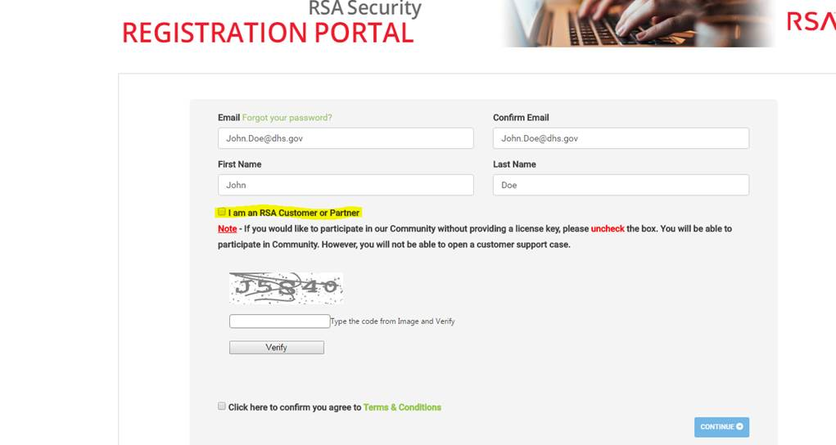

- Click Continue

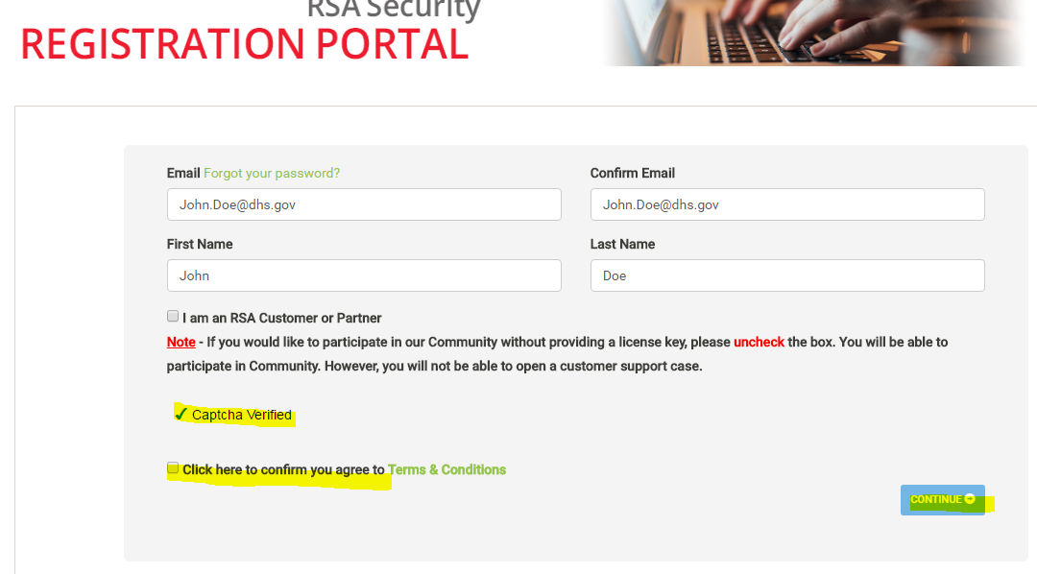

- Set up your ‘3’ Security Questions for Authentication (recommend you not use On-Demand Authentication)
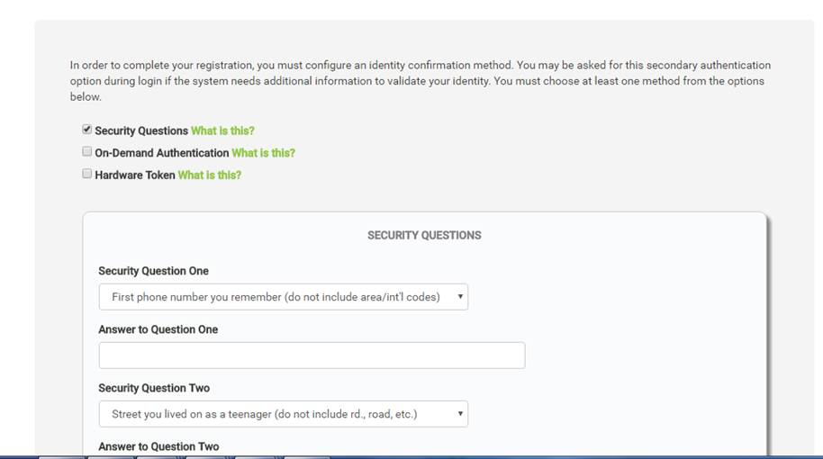

- After configuring your authentication method, you can then click on the blue Continue button, at which point a completion message will be displayed.

- Shortly after you complete the form, you will receive an email from SelfServiceRSA@rsa.com with your temporary password, which you can use when logging in to RSA Link by clicking on the button on the home page.

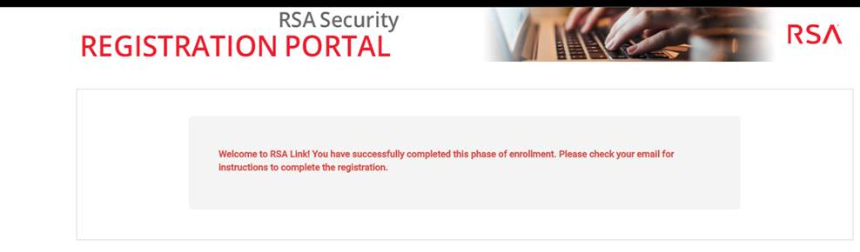
- Once you login with your temporary password, you will be prompted to create a new password for your account; once you do, you can LOGIN with your new Password and your RSA Link registration is complete.

- Now complete the REQUEST ACCESS to Archer Customer/Partner Private Community: https://emcinformation.com/389603/REG/.ashx
and your Form will be processed promptly.

